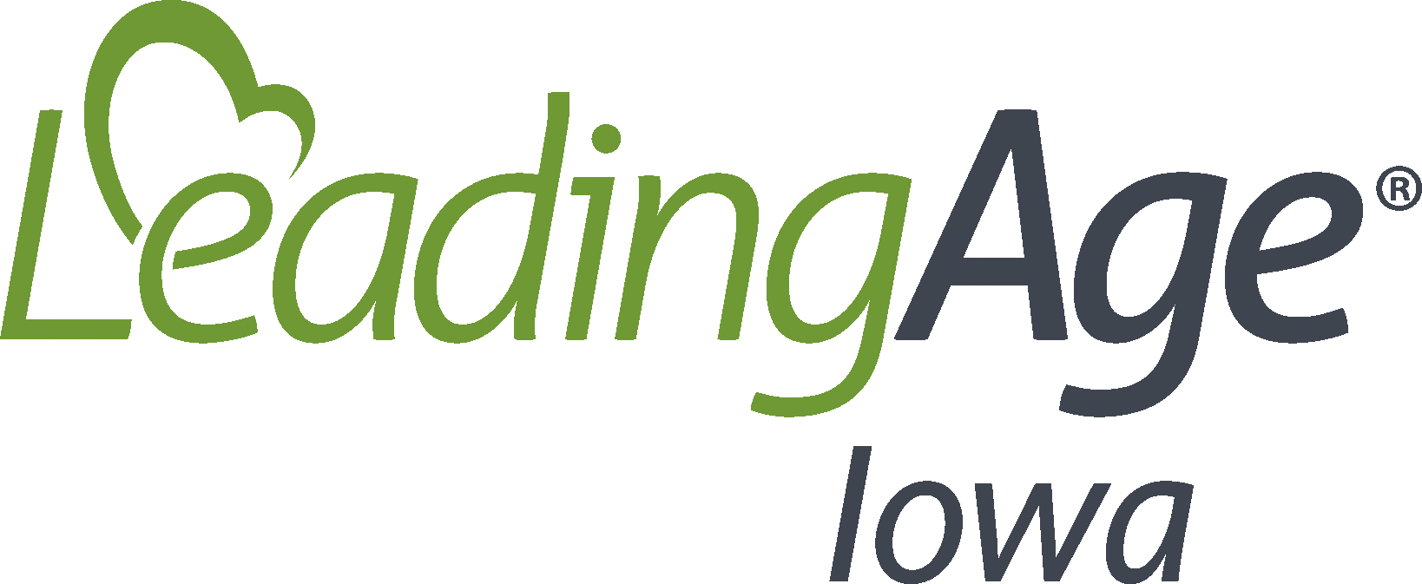
Blood and Body Fluid Cleanup
Date Implemented:
Review/Updated Date:
Policy
It is critical that the environment remains clean and free of communicable diseases for resident, staff, and visitor safety. An effective policy and procedures for cleaning up following a blood and/or body fluid spill or accident is crucial to infection prevention and control.
Procedures
Regardless of the risk-level of an area, spills or contamination from blood or body fluid must be cleaned and disinfected immediately using the following steps:
- The employee must wear appropriate PPE per standard precautions. If the source of the blood or body fluid is known, and the staff are aware of a bacterial or viral infection, additional precautions may be needed. Staff must follow transmission-based precautions in this circumstance. Staff must use the minimum amount of PPE required; however, additional PPE is always available if the staff request it for their safety.
- Confine the spill and wipe it up immediately with absorbent paper towels, cloths or by utilizing absorbent granules and sweeping up the granules carefully. All items utilized to confine the spill and wipe it up must be discarded in a biohazard waste container or bag.
- The area should be cleaned thoroughly using a neutral detergent and warm water solution.
- The area will then be disinfected by using an approved intermediate-level disinfectant. Ensure the disinfectant remains on the area for the contact time indicated by the manufacturer of the disinfectant. If the disinfectant has a longer contact or kill time, additional amounts of disinfectant may be needed to ensure the area remains wet.
- Rinse the area with clean water to remove any disinfectant residue, if necessary.
- Immediately send all reusable supplies and equipment for reprocesses after the spill is cleaned up. Depending on the item, a biohazard bag or identification that the item is contaminated may be needed if sending to another department such as laundry or dietary.
Resources
CDC. (2020, April. 21). Environmental Cleaning Procedures: Best Practices for Environmental Cleaning in Healthcare Facilities: in RLS. https://www.cdc.gov/hai/prevent/resource-limited/cleaning-procedures.html

