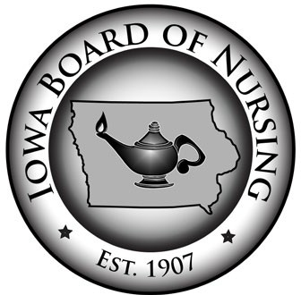
Iowa Board of Nursing
400 S.W. 8th Street Suite B Des Moines, IA 50309-4685
Tel: (515) 281-3255 Fax: (515) 281-4825
Web: nursing.iowa.gov

MEMORANDUM
To: Nurse Licensees, Nursing Employers and Nurse Educators
From: Kathy Weinberg, Executive Director
Date: February 6, 2022
Subject: Termination of Proclamation of Disaster Emergency and Licensing Grace
Period for Nursing Staff Currently Working on Non-Compact, Out-of-State Licenses

On February 6, 2022, Governor Reynolds did not renew her Proclamation of Public Health Disaster Emergency in response to the COVID-19 pandemic. Therefore, the State of Iowa is no longer under a proclaimed state of emergency due to COVID-19.

While the Governor’s Proclamation was in effect, the Board of Nursing’s administrative rules authorized nurses who hold active nursing licenses issued by any state, including a non-Compact state, to immediately begin working to aid the COVID-19 pandemic without first obtaining an Iowa license. See Iowa Admin. Code r. 655-3.2(2)(c). But this rule only allows for nursing practice in Iowa without an Iowa license or multi-state license during a proclaimed emergency. Now that a state of emergency is no longer proclaimed, the Board’s normal licensure requirements apply. Accordingly, all nurses working in Iowa must hold an active Iowa license or an active multi-state license issued by a state that is a member of the Nurse Licensure Compact.

However, to avoid any disruptions in staffing and patient care, the Board is authorizing a grace period to resume compliance with the Board’s normal licensure requirements. Nurses who are presently working in Iowa based on a license issued by a non-Compact state will have NINETY (90) DAYS from the date the emergency was rescinded to obtain an Iowa nursing license. This means nurses will have up to and including May 7, 2022, to obtain proper licensure.

Nurses who hold licenses issued by non-Compact states may apply for licensure by endorsement in accordance with Board rule 655-3.5. Applications may be submitted online through the IBON Online Services. Any nurses who have questions or need assistance with applying for an Iowa license are encouraged to contact the Board office.

