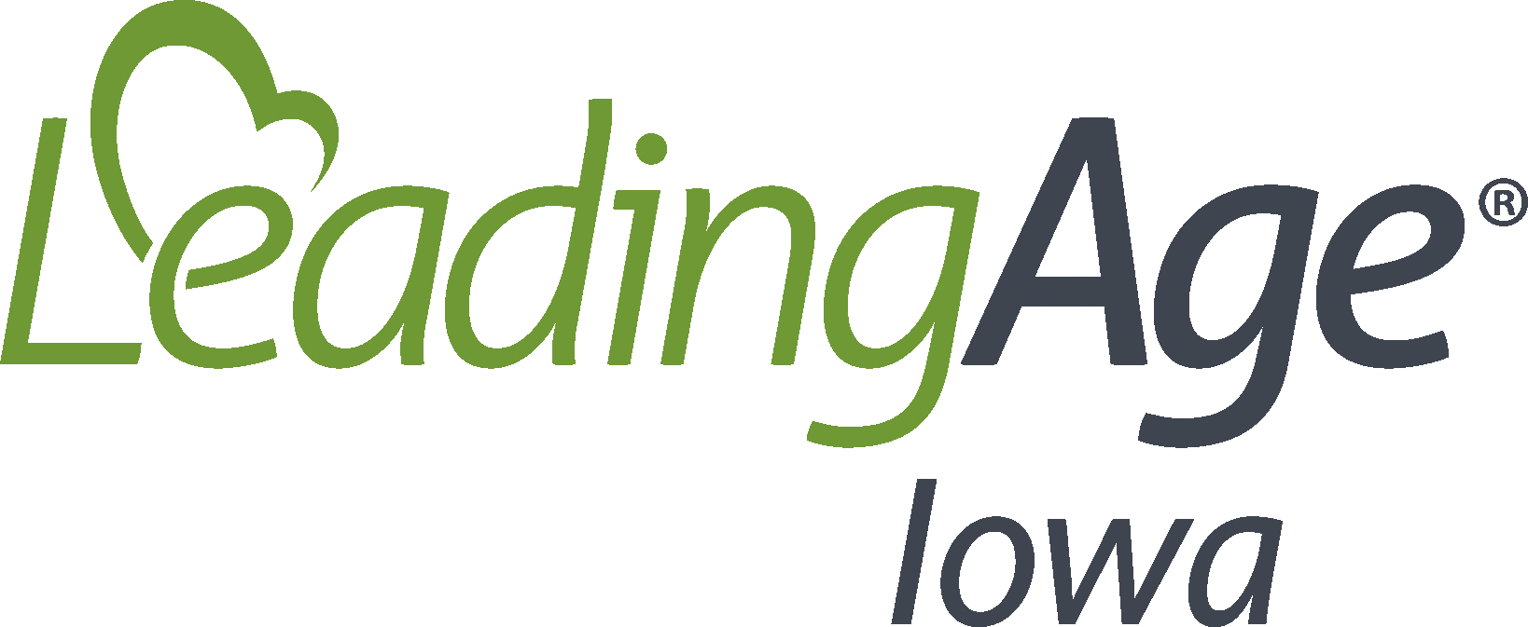
Cleaning and Disinfecting Reusable Resident Care Equipment
Date Implemented:
Review/Updated Date:
Policy
Reusable resident care equipment must be cleaned and disinfected after each use to break the chain of infection.

Definitions
Contact time is the time that a disinfectant should be in direct contact with the item that is being disinfected to ensure that the pathogens specified on the label are killed.
Single-use resident equipment is intended to be used once and then discarded, such as needles and syringes.
Reusable single-use resident equipment can be used more than one time, but must be dedicated to a single resident, such as razors and insulin pens.
Multi-resident equipment may be used for more than one resident after reprocessing (cleaning/disinfection).
Multi-resident care equipment includes but is not limited to:
- Mechanical lifts
- Oxygen and nebulizer equipment (while the machines are considered reusable, parts of the equipment must be single-resident use only such as tubing)
- Commodes
- Vital signs equipment including blood pressure cuffs, stethoscopes, thermometers, and pulse oximeters
- Glucometers and other point of care testing equipment
- Assistive devices such as walkers, wheelchairs, canes, and activity of daily living assistive devices such as sock aides and shoehorns
Cleaning is a manual or mechanical removal of visible soil from an object using water with detergents or enzymatic products. Cleaning reduces the bioburden and removes foreign matter material that could interfere with disinfection or sterilization. Cleaning of equipment should be completed as soon as possible after use.
Sterilization is a method that destroys all microorganisms on the surface of an object and includes steam (autoclave), gas, and/or chemicals.
Disinfection includes:
- Low-level disinfection that destroys all vegetative bacteria (except tubercle bacilli and most viruses). Low level disinfection does not kill bacteria spores. Examples of low-level disinfection include hospital disinfectants registered with the Environmental Protection Agency (EPA) with an HBV and HIV label claim.
- Intermediate-level disinfection kills a wider range of pathogens than a low-level disinfectant. Intermediate-level disinfection does not kill bacteria spores. Intermediate-level disinfection includes EPA registered hospital disinfectants with a tuberculocidal claim and should be considered for non-critical equipment that is visibly contaminated with blood.
- High-level disinfection or sterilization is generally not performed in most nursing homes. If nursing homes complete high-level disinfection, policies and procedures must direct the nursing home how to appropriately perform high-level disinfection and must have a dedicated space for this task. Generally, outside physicians perform procedures (such as podiatry or dental) that require high-level disinfection of their equipment. These providers will bring a necessary number of tools to the nursing home and remove them for high-level disinfection at their office.
Spaulding Classification Scheme includes:
- Critical Equipment that enters sterile tissue or the vascular system including surgical instruments that must be cleaned and sterilized before reuse.
- Semi-critical equipment comes into contact with mucous membranes or non-intact skin. At a minimum, semi-critical equipment requires cleaning followed by high-level disinfection to completely eliminate all microorganisms, except a small number of bacterial spores.
- Non-critical equipment comes into contact with intact skin, but not mucous membranes such as blood pressure cuffs. Non-critical equipment requires cleaning followed by low or intermediate level disinfection.

Procedures
Most equipment used for multiple residents in nursing homes will be considered non-critical. Cleaning and disinfection of non-critical equipment:
- Multi-resident equipment must be cleaned and disinfected after each use.
- Reusable single-resident equipment must be cleaned and disinfected when visibly soiled and on a regular basis (such as daily or several times per week).
- EPA registered disinfectants labeled for use in healthcare must be used. Depending on the type of bacteria or virus a resident may be infected with determines what type of EPA registered disinfectant is used, such as equipment utilized by a resident that was diagnosed with C-diff must be disinfected with germicidal disinfectant.
- Follow the disinfectant’s label for safety precautions related to handling and instructions for product preparation and application.
Application of disinfectants and one-step cleaners and disinfectants:
- Unless the product is a one-step cleaner and disinfectant, cleaning should be performed before disinfection to remove foreign material that can interfere with disinfection.
- The disinfectant should remain wet for the duration of the contact time. If a product has a long contact time, more than one application may be required to assure adequate disinfection occurs. The effectiveness of disinfectants depends on proper use and application. Failure to follow the contact time could leave residual pathogens on the equipment.
- One step cleaners and disinfectants:
  - Distinct cleaning steps may not be required if the item is not grossly soiled.
  - Review the label instructions for use; there may be different steps when the product is used as a cleaner vs. when used as a disinfectant.
Other considerations for the selection of cleaning and disinfectant products:
- Kill claims – what pathogens does the disinfectant claim to kill? Will it cover the most common pathogens identified in the nursing home?
- Contact times – how quickly does the disinfectant kill the listed pathogens? Does the product require multiple applications to achieve the contact time?
- Safety – does the product have acceptable toxicity and flammability ratings? What level of PPE or equipment is necessary when using the product? Is the product compatible with common surfaces and other equipment in the facility?
- Ease of use – does the product clean and disinfect in a single step? Are the directions for use simple and clear? Does the product come in forms such as wipes or sprays that meet your nursing home’s need? Can the product be used in the form provided or is mixing or dilution required?
- Other factors – can the product help standardize the disinfectants used in your nursing home? Is the products odor considered acceptable?

Resources
CMS. (2017, Nov. 2). State Operations Manual, Appendix PP – Guidance to Surveyors for Long Term Care Facilities, F880. https://www.cms.gov/Medicare/Provider-Enrollment-and-Certification/GuidanceforLawsAndRegulations/Downloads/Appendix-PP-State-Operations-Manual.pdf
CDC. (2020, June 10). Infection Prevention Training | LTCF. https://www.cdc.gov/longtermcare/training.html

