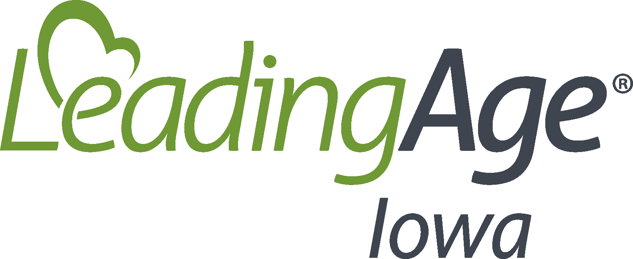
Environmental Cleaning
Date Implemented:
Review/Updated Date:
Policy
The environment of the nursing home shall be cleaned and/or disinfected on a routine basis to assist with infection prevention and control, an environment free from pests and rodents, and overall appearance.
Environmental surfaces refer to surfaces of resident care equipment and non-resident care equipment. Environmental surfaces are classified into two areas including those with minimal hand contact such as the floors and ceilings and those with frequent hand contact, also known as high-touch surface areas including doorknobs, bed rails, call lights, light switches among many others.
Since various pathogens can survive for long periods of time while resting on an item it is vital for proper cleaning and disinfection to occur to break the chain of infection.
The process of cleaning refers to removing visible soil from surfaces through the physical action of scrubbing with a surfactant or detergent and water. Cleaning reduces the volume of organisms on a surface and removes foreign material that could interfere with disinfection.
Disinfection includes low-level, intermediate-level and high-level disinfection. High-level disinfection is generally associated with sterilizing equipment and is typically not done in a nursing home setting. Low-level disinfection destroys all vegetive bacteria (except tubercle bacilli) and most viruses but does not kill bacteria spores. Low-level disinfection is generally appropriate for most environmental surfaces. Low-level disinfectants should be registered with the EPA and have an HIV and HBV kill claim. Intermediate-level disinfection kills a wider range of pathogens than a low-level disinfection but still does not kill bacterial spores. Intermediate-level disinfectants are EPA registered and have a tuberculocidal claim. Intermediate-level disinfection should be considered for all items contaminated or potentially contaminated with blood.
For cleaning and disinfection of residents’ care equipment and supplies, see alternate policy titled: Cleaning Reusable Resident Care Equipment.

Procedures
The housekeeping department will establish a standardized process to ensure that cleaning and disinfecting of the environment is being completed on a routine basis. Considerations to this standardized process include:
- Always working from the cleanest surfaces to the dirtiest surfaces. For example, the resident’s bathroom will be the last area cleaned in the resident room.
- Always work from the top of the room to the bottom of the room.
- Establishing a consistent process or pattern for cleaning and disinfecting surfaces in each room.
- Wiping surfaces in a manner to prevent recontamination.
The housekeeping department will ensure that cleaning equipment and cleaners/disinfectants are always utilized in the appropriate manner including:
- Changing cleaning cloths frequently.
- Changing mop heads after use in each room.
- Environmental service carts will not enter resident rooms. The supplies will be brought into each room and will be limited to the minimum necessary for that area.
- Procedures will be established for the frequency of cleaning and disinfection of each area.
Guidelines for frequency of cleaning and disinfection:
- Resident Rooms:
  - High touch surfaces are those most likely to be touched by residents and staff and pose the highest risk for pathogen transmission. Examples include bedrails, doorknobs, light switches. High touch surfaces will be cleaned daily.
  - Horizontal surfaces with infrequent hand contact such as floors and windowsills will be cleaned on a regular basis and as needed such as when spills occur and if the area is visibly soiled.
  - Terminal cleaning of a resident room will be performed when a resident moves out of the room including changing of room and/or discharge. Terminal cleaning includes:
    - All high-touch surface areas will be cleaned and disinfected.
    - Horizontal surfaces with infrequent hand contact will be cleaned and disinfected.
    - All linens, including sheets, towels and privacy curtains will be bagged and removed for laundering.

- Procedure and Treatment Areas:
  - Generally invasive treatment areas are not utilized in a nursing home setting. However, if an invasive treatment area is present and utilized in a nursing home, this area will be cleaned and disinfected following each procedure.
  - Non-invasive treatment areas (such as therapies or gyms) will be cleaned and disinfected:
    - At least daily.
    - When visibly soiled.
    - Equipment will be cleaned following each use as directed in the reusable care equipment policies and procedures.
    - Following use by a resident that is colonized or infected with a highly resistive organism.
- Common Areas:
  - High touch surface areas in the common areas will be cleaned on a regular basis, such as daily and when soiled or visibly dirty.
- Carpeting:
  - Carpeting is harder to keep clean and cannot reliably be disinfected, especially after spills of blood or bodily fluids.
  - Nursing homes are encouraged to not place carpeting in high traffic zones, such as resident care areas, where spills or blood/bodily fluids are more likely to be on the carpet.
  - Carpeted areas will be vacuumed on a regular basis with equipment designed to minimize dust dispersion.
  - Carpeted areas will be periodically deep cleaned using a method that minimized production of aerosols and leaves little to no residue.
  - Carpeting will be will spot cleaned following any spills of blood or bodily fluid.
- Upholstered Furnishings:
  - Upholstered furnishings present challenges with cleaning and disinfection. When possible, nursing homes will encourage residents to bring in their own upholstered furnishings to prevent cross-contamination between residents.
  - Residents will be encouraged to leave upholstered furnishings in their rooms to minimize use by other residents. Use of upholstered furnishings will be discouraged in common areas.
  - Residents’ upholstered furnishings will be kept in good repair. If a defect is noted in the furnishing, the nursing home will coordinate repair with the resident and/or resident’s representative. If repair is unable to be completed, the resident and/or their representative will be encouraged to replace the furnishing. However, resident’s rights allow for the resident to have their personal belongings, if the resident is insisting on maintaining the damaged furnishing and all attempts have been made to repair, the nursing home will document in the resident’s records effort to repair and discussion on removal of the item and the resident’s desires to retain the item.
  - Residents’ upholstered furnishings will be cleaned on a routine basis and when visibly soiled. If the furnishing needs cleaning (such as by a carpet cleaner), the item will be removed from the resident’s room and will be cleaned thoroughly and returned to the room when dry. The resident or their responsible party will be notified of removal from their room for cleaning.
Training on cleaning of environmental surfaces will be conducted on hire and at least annually. If new products are introduced, all housekeeping staff will be educated on the new product including the appropriate indications for use, how to apply the cleaner/disinfectant and the contact time/kill time for the disinfectant. The nursing home will maintain a list of MSDS sheets as a part of the Safety and Hazard program required by OSHA.
Supplies:
- Supplies in adequate quantity will be maintained in the housekeeping storage room. Housekeepers should assure appropriate quantities of cleaning/disinfecting equipment are maintained on the environmental services cart to complete duties. Storage of any hazardous chemicals will be maintained behind a locked door or cart to ensure resident safety.
- Clean and Dirty supplies will be maintained in a separate location/area to prevent cross contamination.
- Environmental service carts will be cleaned on a routine basis to ensure the carts are not contaminated and potentially contaminating clean equipment on the cart.
Performance Monitoring:
- Housekeeping staff will be monitored periodically for compliance with recommended cleaning/disinfecting procedures and protocols. There are various methods to monitor cleanliness of the environment including by not limited to:
  - Direct observation of staff during cleaning/disinfecting or direct observation following cleaning/disinfecting of an area.
  - Florescent markers may be applied prior to staff cleaning and then assessed with special lighting following cleaning of the area.
  - Adenosine triphosphate (ATP) Bioluminescence assay systems that measure residual organic matter including microbial and non-microbial that remains on a surface following cleaning. This method will identify residual particles but will not identify deviations of practice that contributed to residual particles.
  - Culturing of Surfaces, however, culturing of surfaces is generally not recommended and may be completed only in consultation with the county public health department as part of an outbreak investigation.
- Performance monitoring shall be included in the nursing home’s QAPI program.

Resources
CMS. (2017, Nov. 2). State Operations Manual, Appendix PP – Guidance to Surveyors for Long Term Care Facilities, F880. https://www.cms.gov/Medicare/Provider-Enrollment-and-Certification/GuidanceforLawsAndRegulations/Downloads/Appendix-PP-State-Operations-Manual.pdf
CDC. (2020, June 10). Infection Prevention Training | LTCF. https://www.cdc.gov/longtermcare/training.html

