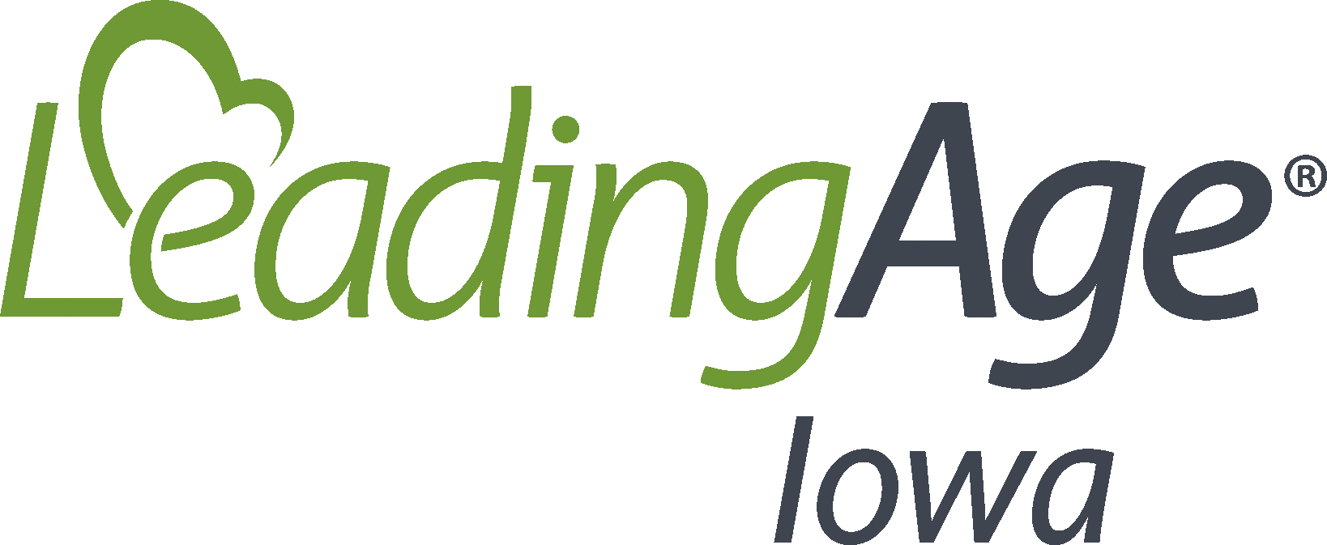
Pets or Animals in Long-Term Care Settings
Date Implemented:
Review/Updated Date:
Policy
Animals in long-term care facilities provide the potential of transmission of zoonotic pathogens from animals to humans. Although dogs and cats may be commonly encountered in health care settings, other animals such as fish and birds, may also be present. Animals potentially can serve as reservoirs for antibiotic-resistant microorganisms, which can be introduced to the health care setting while the animal is present.
Zoonoses can be transmitted from animals to humans either directly or indirectly via bites, scratches, aerosols, ectoparasites, accidental ingestion, or contact with contaminated soil, food, water, or unpasteurized milk.
Animal-assisted activities and therapies including resident animals are programs that enhance the resident’s quality of life. Decisions on resident’s participating in animal programs should be made on a case-by-case basis and in consultation with the attending physician, the resident and/or representative and the interdisciplinary care team.
Procedures
Animals participating in animal-assisted activities and therapies and/or resident animals must be up to date with recommended immunizations and prophylactic medications including heartworm prevention and flea/tick prevention. Long-term care providers should maintain copies of vaccination records for routine animals that visit the center. Regular re-evaluation of the animal’s health and behavior status is essential. Animals coming into the building should be free of sutures, open wounds, and/or obvious dermatologic lesions that could be associated with bacterial, fungal, or viral infections or parasitic infestations. Animals should be clean and well-groomed. If the animal-assisted activity or therapy includes a trainer or handler, the trainer or handler should also be in good health.
The most important infection prevention and control measure to prevent disease transmission is strict enforcement of hand hygiene measures, including use of alcohol-based hand rub (ABHR) for all residents and staff before and after handling the animals.
Care should also be taken to avoid direct contact with animal urine or feces. Cleaning up these substances from environmental services should be completed with appropriate PPE and the use of leak-resistant plastic bags to discard absorbent material used in the process. The area must be cleaned and disinfected according to standard cleaning procedures. If the building has a resident cat, strict procedures should be followed for cleaning of the litter box, including PPE, disinfection/sanitation, hand hygiene, and discarding of feces and urine clumps.
In the event a resident is bitten by an animal visiting the building, the staff should follow procedures related to incident reports and wound documentation. In addition, the bite should be cleaned immediately and routinely monitored for subsequent infection. If signs or symptoms of infection are noted, the residents primary care physician must be notified, and treatment directives followed.
Fish tanks or aquariums should be cleaned on a regular basis by a staff member that is not in charge of providing resident care. Appropriate PPE should be utilized while cleaning fish tanks or aquariums, including hand hygiene. Residents should never touch the fish.
As a general preventative measure, resident animal programs are advised to restrict animals from food preparation areas, laundries, central sterile supply, and any storage areas for clean supplies and medication preparation areas. Resident-animal or animal-assisted activities should not be conducted in resident rooms that are considered transmission-based precautions or touched by residents that are in transmission-based precautions.
Service Animals:
Because health care providers are covered by the ADA, a person with a disability may be accompanied by a service animal within the facility, unless the animal’s presence or behavior creates a fundamental alteration in the nature of a facility’s services in a particular area or a direct threat to other persons in a particular area. A “direct threat” is defined as a significant risk to the health or safety of others that cannot be mitigated or eliminated by modifying policies, practices, or procedures. The determination that a service animal poses a direct threat to any particular health care setting must be based on an individualized assessment of the service animal, the resident, and the health care situation. When evaluating risk in such situations, health care personnel should consider the nature of the risk (including duration and severity); the probability that injury will occur; and whether reasonable modifications of policies, practices, or procedures will mitigate the risk. The person with a disability should contribute to the risk-assessment process as part of a pre-procedure health care provider/resident conference.
Excluding a service animal from a particular special care area or unit is appropriate if these areas are considered to have restricted access with regards to the general public. General infection-control measures that dictate such limited access including:
- The area is required to meet environmental criteria to minimize the risk of disease transmission;
- Strict attention to hand hygiene and absence of dermatologic conditions; and
- Barrier protective measures (such as gloves, gowns, and masks) are indicated for persons in the affected space.

Resources
CDC. (2015, Nov. 5). Background H. Animals in Health-Care Facilities: Guidelines for Environmental Infection Control in Health-Care Facilities. https://cdc.gov/infectioncontrol/guidelines/environmental/background/animals.html

