This room is electronically monitored.
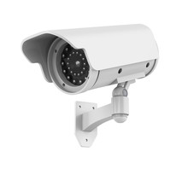
Some residents may be monitored electronically by or on behalf of the residents.

